Exercise 13 Output
Vanessa Belous
Nov 20th, 2025

Screenshots:
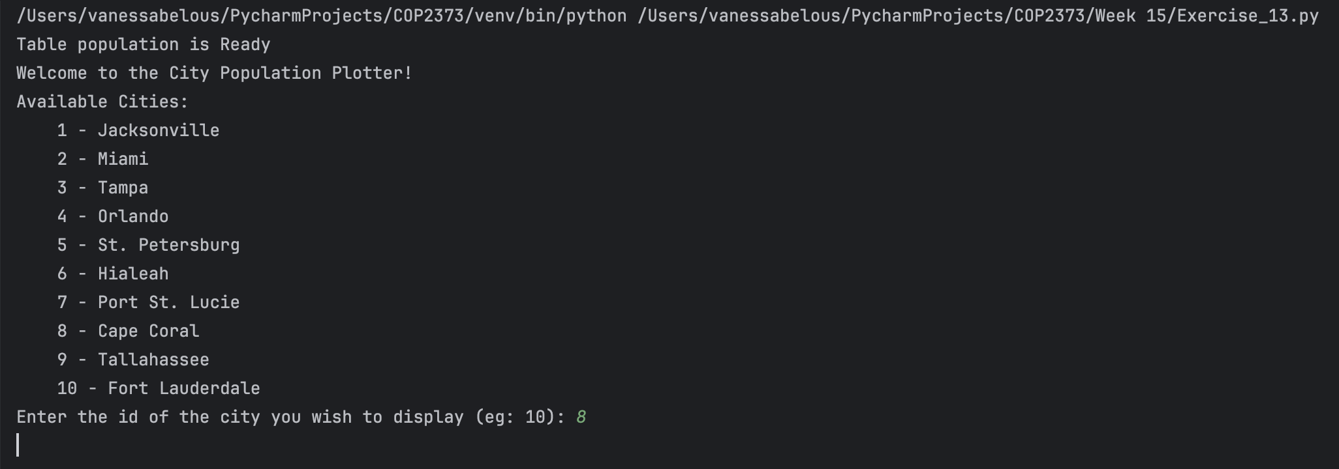
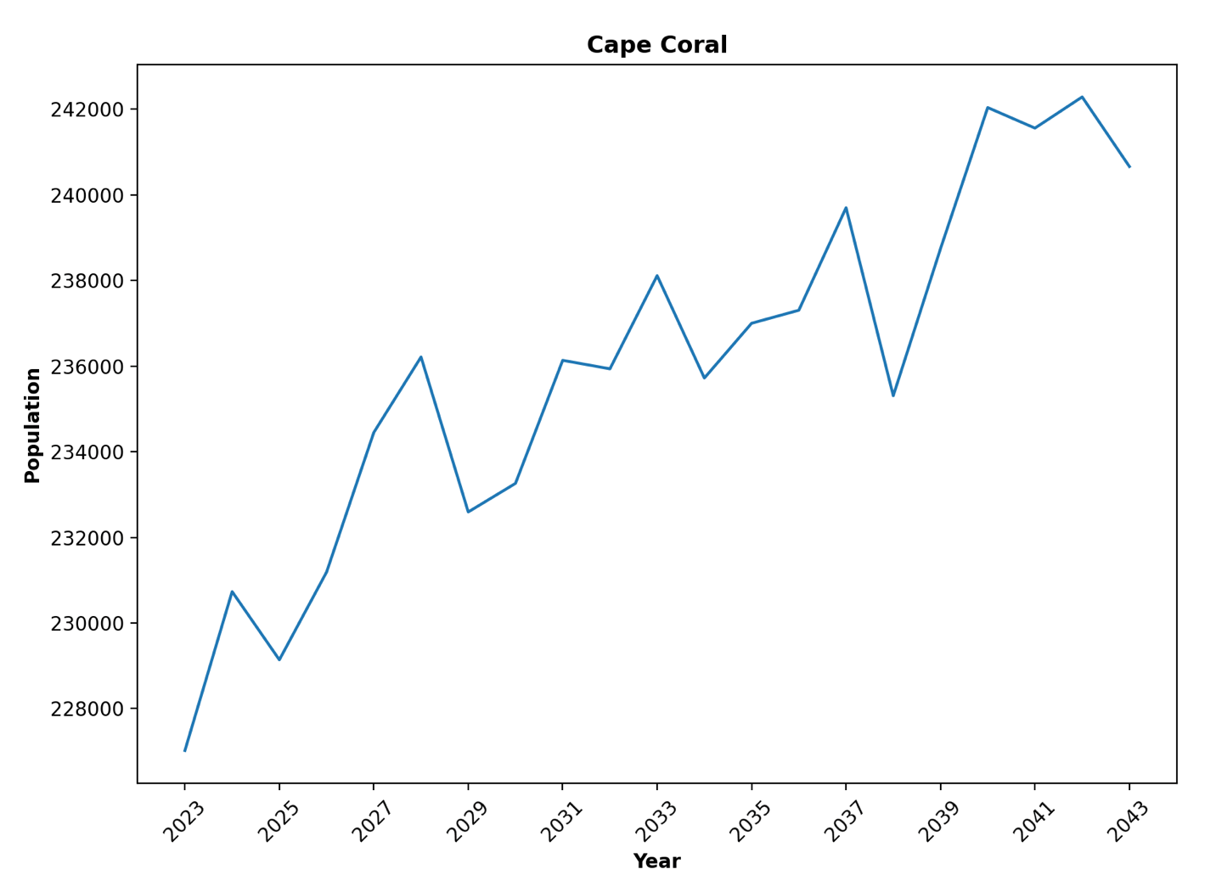
Repository Link: https://github.com/VBelous1/COP2373/tree/master/Week%2015

